

SUGAR Manual
Revision History
1.18.18 | SAM | Reinstating and Adding a License
05.18.18 | EML | Sales forms for Sugar
03.21.19 | AJL | Complete edit, additions, and reposted to intranet
03.28.19 | EML/AJL | Added logging into Sugar, global search, and updating outlook password
PG Calc
Contents
Logging in to Sugar……………………………………………………………………………………………………………………………………………………………2
Search for an Organization 2
Search for an Organization – With a Filter 2
Search for a Name – Without a Filter 3
Search for a Name – With a Filter 3
Log a Call 4
View and Edit a Service Contract Primary Contact 5
Add a New Name to an Organization 7
View and Edit a Service Contract Additional User 11
Lapsing a License (NOT Primary License) 12
Reinstating a License (NOT Primary License) 14
Adding a License (NOT Primary License) 14
Making a Name Inactive 15
Deleting Service Name Without Making Name Inactive 16
Finding a Product’s Platform 16
MIS Issue Tracking 17
Creating an Invoice (Quote) 18
Processing credit card orders for new/reinstated software orders (not renewals): 26
Editing an Existing Invoice 27
Create All Documents for Renewal Invoices…………………………………………………………………………………………………………………...27
Quote Stages and Payment Terms 28
Adding an IT Contact to a Service Contract 29
Update Outlook Password………………………………………………………………………………………………………………………………………………30
Editing and Creating an Email Signature………………………………………………………………………………………………………………………….31
Sending and Creating an Email Template……………………………………………………………………………………………………………………..…32
Merging Organizations…………………………………………………………………………………………………………………………………………………...34
Merging Names………………………………………………………………………………………………………………………………………………………………36
Create an Organization……………………………………………………………………………………………………………………………………………………37
Linking Calls to a Name Record……………………………………………………………………………………………………………………………………….39
Linking Existing Records………………………………………………………………………………………………………………………………………………….40
Sales Forms for Sugar 41

Logging into Sugar

Go to https://pgcalc.sugarondemand.com to log into your account. *Bookmark this link.

Enter your User Name and Password. Using the “Forgot Password?” link will allow you to reset your password.

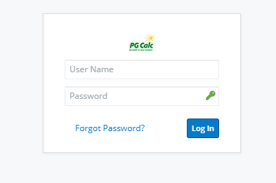

If you have questions about your login information or account, please see David Kelly.

Search for an Organization

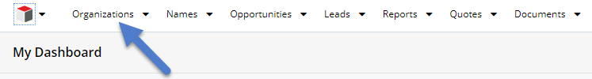

Without a Filter
- Locate the white toolbar at the top of your screen
- Click on any portion of the text “Organizations”
- Enter the desired Organization name in the search text box “Search by org name…”
- Allow the search screen to paint, hitting the Enter key is not needed
SEARCH TIP! Add a percentage sign (%) in front of search terms. For example, entering “Humane Society” will not pull up “The Humane Society,” but “%Humane Society” will. Do not enter a space between % and the search term.

Search for an Organization – With a Filter
With a Filter

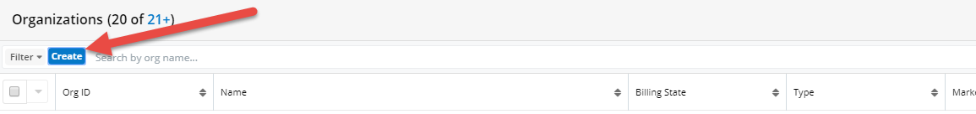

- Locate the white toolbar at the top of your screen
- Click on any portion of the text “Organizations”
- Click “Create” within blue text
- A drop-down menu will appear, select your desired filter from the menu
- For most searches, choose “exactly matches” from the second drop-down menu that appears to the right of the filter drop-down menu
- Enter the desired number or text into the text box that appears on the far right
- To include additional filters, click the plus symbol next to the text box in step five. (Filters can also be removed by clicking the minus symbol)
- Allow the search screen to paint, hitting the Enter key will clear your results
- Save your filter by entering a filter name into the text box “Enter new filter name…” and click the blue “Save” button on the far right
- Your saved filter will now appear in the Filter drop-down menu to the left of “Create” listed in step four

Search for a Name – Without a Filter

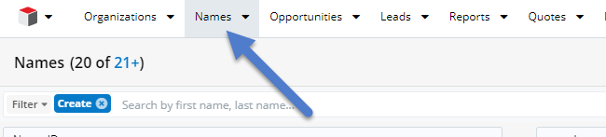
Without a Filter
- Locate the white toolbar at the top of your screen
- Click on any portion of the text “Names”
- Enter the desired Name in the search text box “Search by first name, last name…”
- Allow the search screen to paint, hitting the Enter key will clear your results

SEARCH TIPS!
- Add a percentage sign (%) in front of search terms. For example, entering “Robert Jones” will not pull up “M. Robert Jones,” but “%Robert Jones” will. Do not enter a space between % and the search term.
- The preview button shown below (the eye) is always available to see a Name record in more detail.

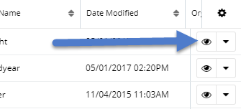

Search for a Name – With a Filter
With a Filter

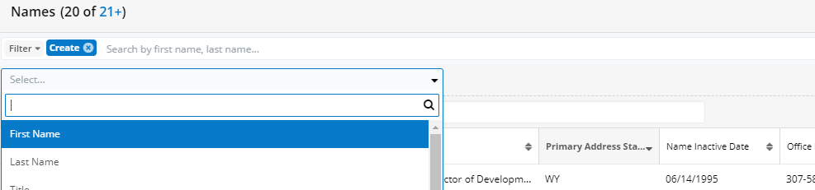

- Locate the white toolbar at the top of your screen
- Click on any portion of the text “Names”
- Click “Create” within blue text
- A drop-down menu will appear, select your desired filter from the menu
- For most searches, chose “exactly matches” from the second drop-down menu that appears to the right of the filter drop-down menu
- Enter the desired number or text into the text box that appears on the far right
- To include additional filters, click the plus symbol next to the text box in step five. (Filters can also be removed by clicking the minus symbol)
- Allow the search screen to paint, hitting the Enter key will clear your results
- Save your filter by entering a filter name into the text box “Enter new filter name…” and click the blue “Save” button on the far right
- Your saved filter will now appear in the Filter drop-down menu to the left of “Create” listed in step four

Log a Call

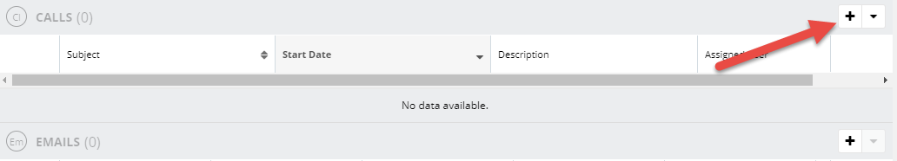
- The “Calls” module is located directly below a given Organization or Name record
- Calls are logged by Name, not Organization
- Search for a Name
- Once in the desired Name record, toggle to the far right of the screen to add a Call with the “+” symbol
- Enter the desired information in the Call record form based on your call, several fields are notated as required
- Click the blue “Save” button to save your Call
- You will be directed back to the given Name record and can view your call
- Do you want to revise or add new information to your call? Click the pencil symbol at the far right of your call record to make appropriate changes, or click on the Call’s subject to open and edit
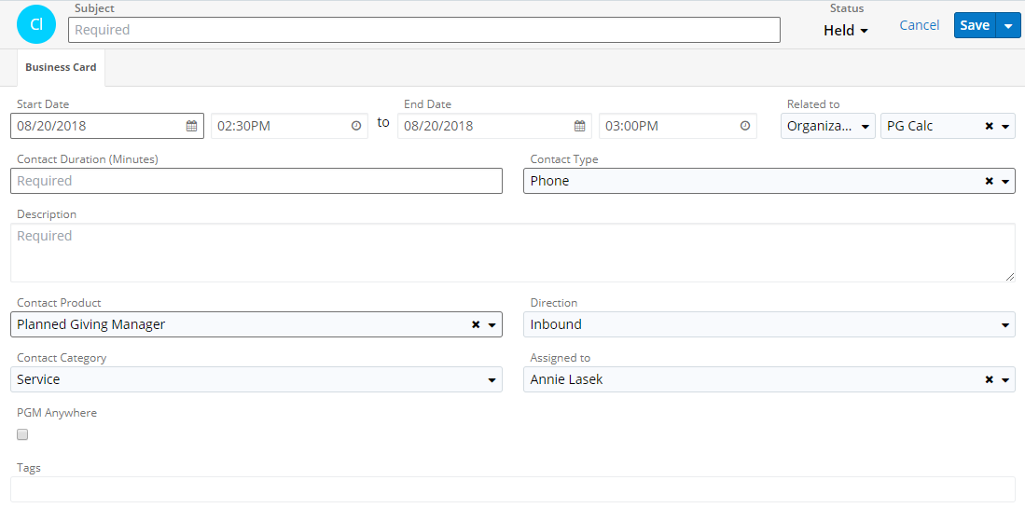

SEARCH TIPS!
- Calls can be filtered by Subject, Name, Start Date, Contact Product, Assigned User, and Contact Type
- Hover over a desired text field to view the full text, i.e. a Call Description

View and Edit a Service Contract Primary Contact
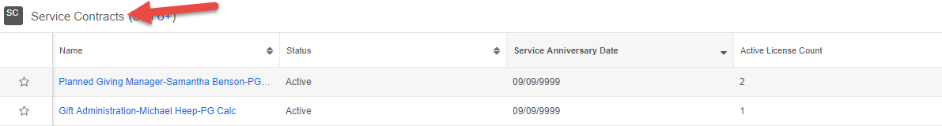
On your desired Organization page, scroll down to “Service Contracts (SC)” and click the appropriate Service Contract "Name" on the far left (EX: Planned Giving Manager-Joe Smith-PG Calc).

Scroll down to “Service Names (SN)”to change the Service Name with the “Contact Type” of Primary Contact.

Edit the Service Name by clicking “Service Name Detail” for the Primary Contact.
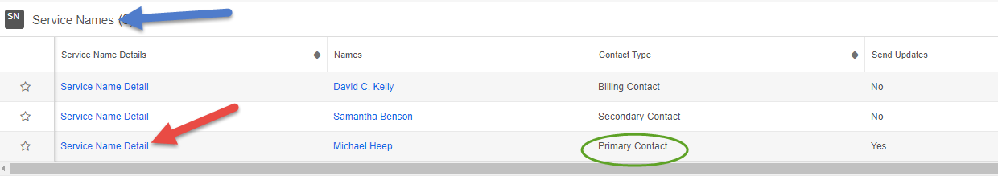

Edit “Names” by hovering over the “Names” field and clicking the pencil icon.

Click “Search and Select…” to find your desired Name. Note that this will bring you to a new “Names” search screen.

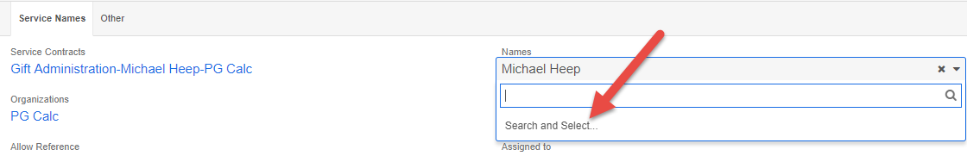

Type in the desired name in the top text box and let the search screen paint. Click the radio button to the far left to select the desired Name.

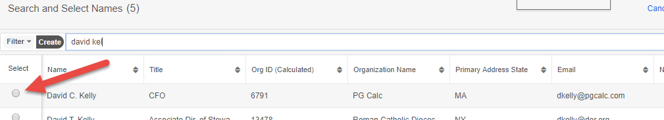

This will bring you back to the service name record. Edit “Organization” by clicking on “Select Organization…”. Click “Search and Select…” to find your desired Organization.

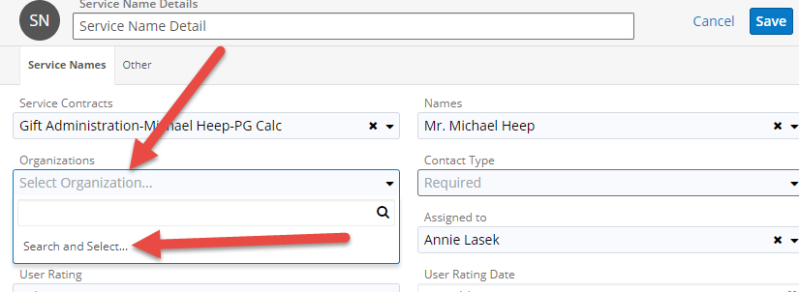

Type in the desired Organization in the top text box and let the search screen paint. Click the radio button to the far left to select the desired Organization.

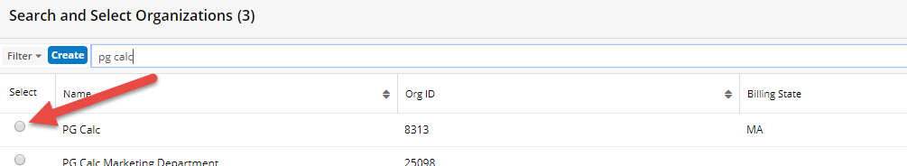

This will bring you back to the service name record. Edit the “Contact Type” by clicking on the “Required” field under “Contact Type”.

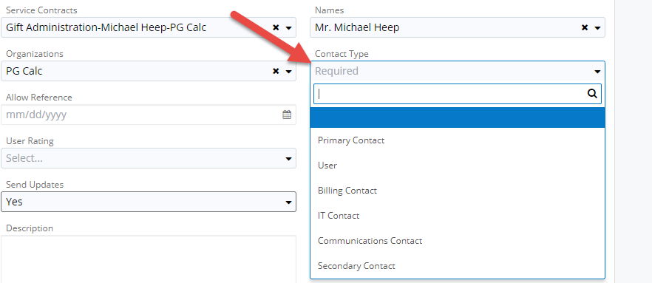

Finally, look at the “Send Updates” field. Typically, the Billing Contact does not need to receive updates. The primary contact, user, and IT contact should receive updates.

Add a New Name to an Organization

Names were formerly added to Organizations using a blue “Add New Name” button in an Organization record.
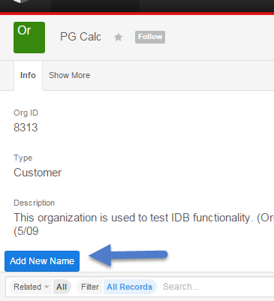
This button has been removed, replaced with a new subpanel under Organizations called “Add New Name.” *Please note that this subpanel will be located at the very bottom of an Organization record. You can drag and drop the “Add New Name” subpanel to any location you wish, we recommend directly below the “Calls” subpanel.
Before adding a new Name to an Organization, please consult the “Names”, “Active Names”, and/or “Inactive Names” subpanels to confirm they are not already listed at the Organization. You can also doublecheck by searching for the Name under the Name tab located at the top of the screen to the right of Organizations. Note that the Name may be listed as “Robert Smith” instead of “Bob Smith” or vice versa. (You will also be able to confirm they are not currently in Sugar when you add the Name).

- “Active Names” subpanel – lists all active Names at an Organization
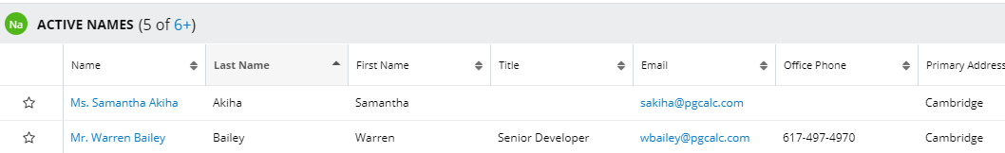
- “Inactive Names” subpanel – lists all inactive Names at an Organization
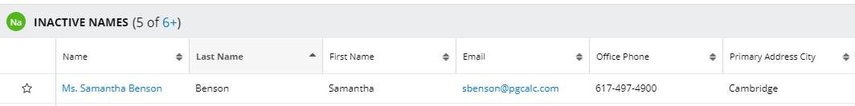
Please do not click the + to add a record to the “Active Names” or “Inactive Names” subpanels. All names are added in the “Add New Name” subpanel.

If the Name is not already listed at the Organization, click the + to the far right of the “Add New Name” subpanel.

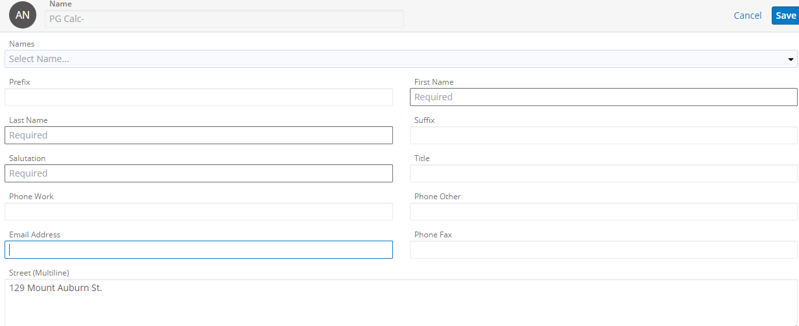
The “Add New Name” form pre-populates with stored contact information for the (most likely) last added Name to the Organization you are adding to.
Begin by clicking “Names” in the top left, then immediately click “Search and Select…”
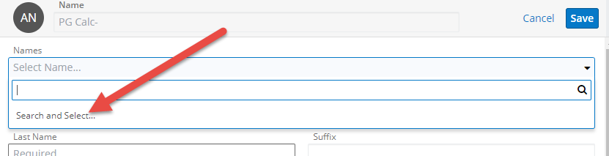

You will be brought into the Names Search table. *Note that this is the entire Sugar Names table and not specific to the given Organization.
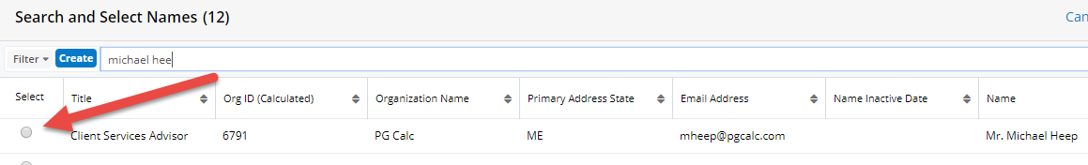
Search in the text box for the Name. If the Name is currently in Sugar (most likely at a former Organization), select this Name by clicking the radio button on the left. This will relate the Name to current and former Organizations.
IF THE NAME DOES NOT APPEAR in the “Names” search, click “Cancel” in the top right to go back to the “Add New Name” form.
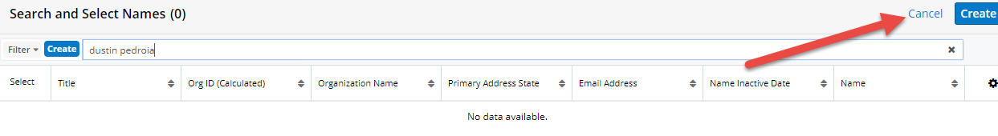
If you selected a Name, it populates in the “Prefix”, “First Name”, “Last Name”, “Salutation,” and “Suffix” (if applicable) fields. The Organization contact information pertains to the Name’s new Organization.
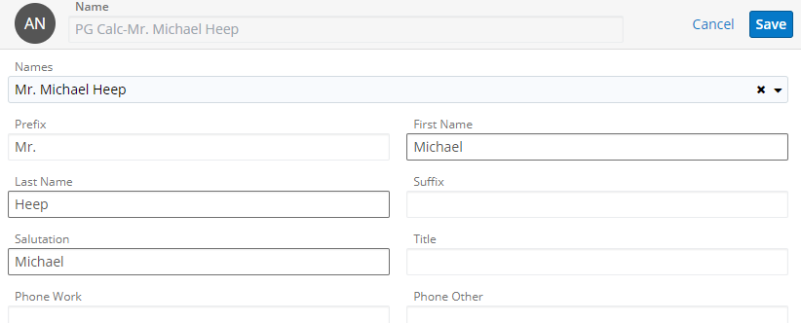
Confirm/enter the appropriate contact information and click the blue Save button in the top right. *“First Name,” “Last Name,” “Salutation,” “City,” and “State” are required fields. *
A few notes:
- In the “Prefix” field, enter “Mr.” for men and “Ms.” for women. If the contact’s gender isn’t clear, leave it blank.
- If the contact has a middle initial or name, include it in the “First Name” field.
- If you add a “Suffix,” add a comma and a space before it (e.g., “, J.D.”).
- In the “Salutation” field, enter either the contact’s first name or their nickname if they provide one. This is the field that we use to address people in our mass emails.
- Please use abbreviations for states.
A screen may appear asking if you want to Ignore Duplicates and Save. Please click the blue button “Ignore Duplicate and Save.”
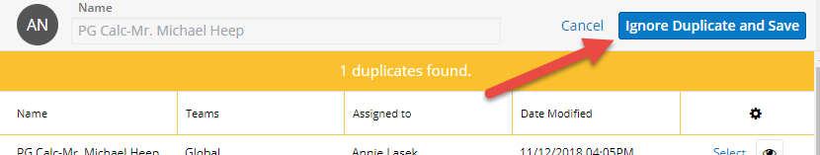
After saving, you are brought back to the Organization screen. Scroll down to the “Add New Name” subpanel to see the added Name. Click the hyperlink in the “New Name” column to view your Name.
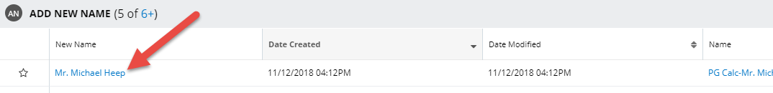

View and Edit a Service Contract Additional User
On your desired Organization page, scroll down to “Service Contracts (SC)” and click the appropriate Service Contract "Name" on the far left (EX: Planned Giving Manager-Joe Smith-PG Calc).

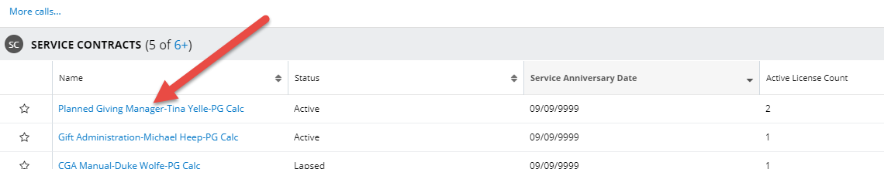

Scroll down to “Service Names (SN)”to change the appropriate Service Name with the “Contact Type” of User.
Edit the Service Name by clicking “Service Name Detail” for the appropriate User.
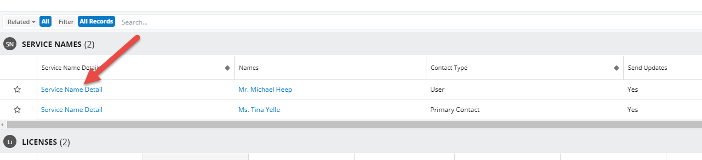

Edit “Names” by hovering over the “Names” field and clicking the pencil icon.
Click “Search and Select…” to find your desired Name. This opens a new “Names” search screen, starting a new search.

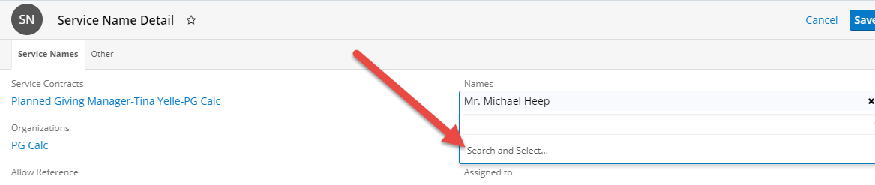

Enter the desired name (again) in the top text box and let the search screen paint. Click the far-left radio button to select the desired Name.

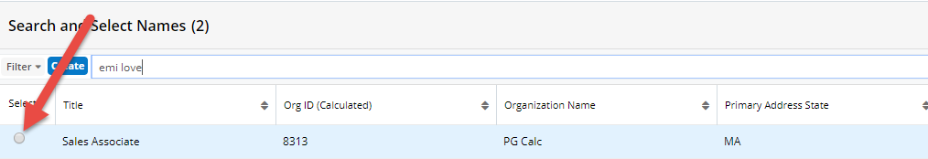

Once back in the Service Name Detail record, note the correct Org should already be listed. If you are adding a new service name, the Org does not auto-populate and would need to be added. Confirm Org listed is correct then click Save.
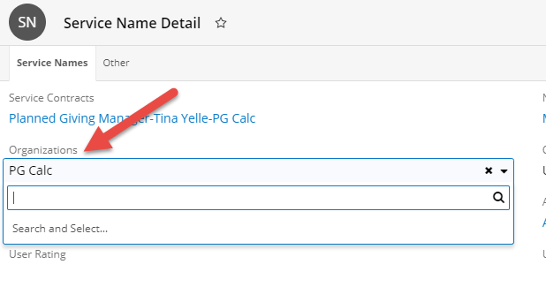

Lapsing a License (NOT Primary License)

- Access a given Organization
- Scroll down to the Service Contracts and click the far-left link to the respective product Service Contract
- Within the Service Contract, scroll down to Licenses
- Click the far-left “License Details” of the desired License (copy) you wish to lapse

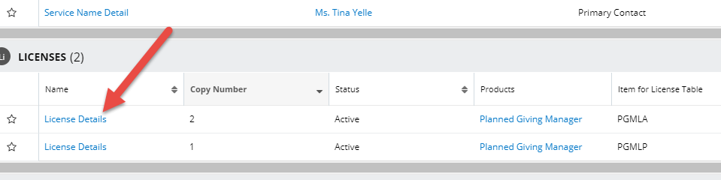

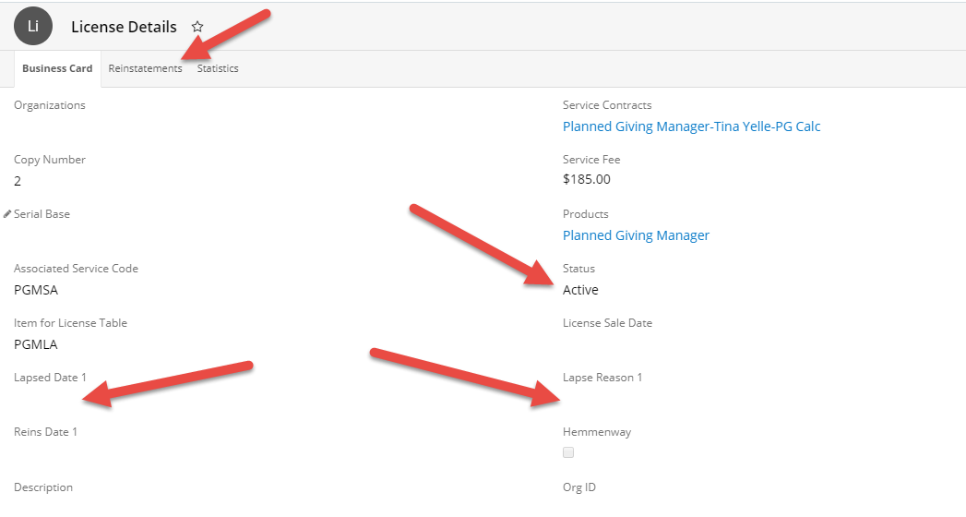
- Within the License record, update “Status” from “Active” to “Lapsed”
- Update the “Lapsed Date 1” with the next Service Anniversary Date
- Update “Lapse Reason 1” with the appropriate lapse reason from the drop-down menu
- If “Lapsed Date 1/Lapse Reason 1” are already filled in, continue to the next consecutive number to record the lapse and reason. This is now located under the “Reinstatements” tab
- Click the link back into the given Service Contract, scroll down to Service Names
- Click the “Service Name Detail” for the licensee that has lapsed

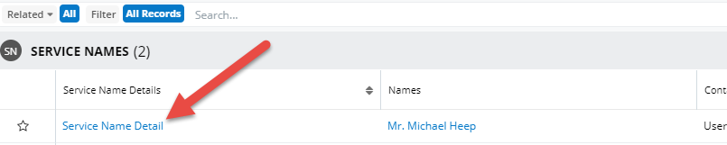

- Access the blue Edit drop-down menu in the top right of the Service Name, click Delete

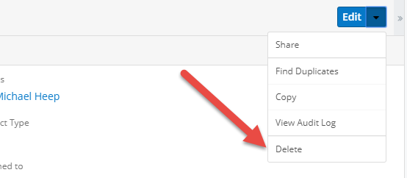

- Mark Name as Inactive if necessary, by editing Name Inactive Date on Name screen
- ***PLEASE NOTE: Update System Applications if necessary. For Example, updated number of registered users in PGM Anywhere
NOTE THIS IS THE ONLY PLACE TO DELETE A RECORD!

Reinstating a License (NOT Primary License)
- Access a given Organization
- Scroll down to the Service Contracts and click the far-left link to the respective product Service Contract
- Within the Service Contract, scroll down to Licenses
- Click the far-left “License Details” of the desired License (copy) you wish to reinstate (using the appropriate Copy Number if there are multiple lapsed licenses).

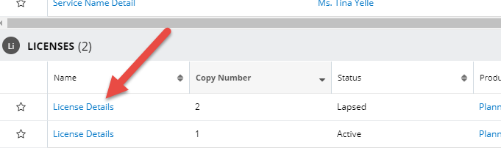

- Within the License record, update “Status” from “Lapsed” to “Active”
- Update the “Reins Date 1” with the appropriate date

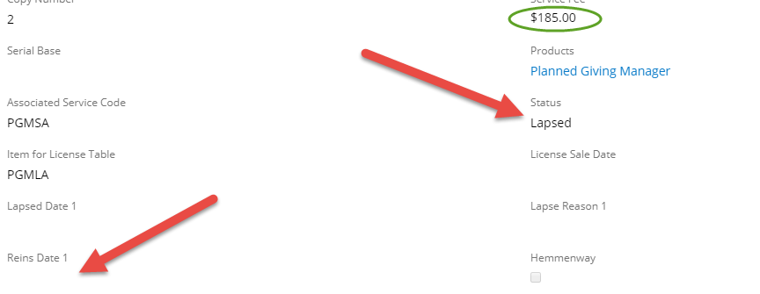
- If “Reins Date 1 is already filled-in, continue to the next consecutive number to record. The rest of reinstatements are under the “Reinstatements” tab under License Details
- PLEASE NOTE that the Service Fee is correct for the license you are reinstating. You may need to update.
- Click Save

Adding a License (NOT Primary License)
- Access a given Organization
- Scroll down to the Service Contracts and click the far-left link to the respective product Service Contract
- Within the Service Contract, scroll down to Licenses and click the +
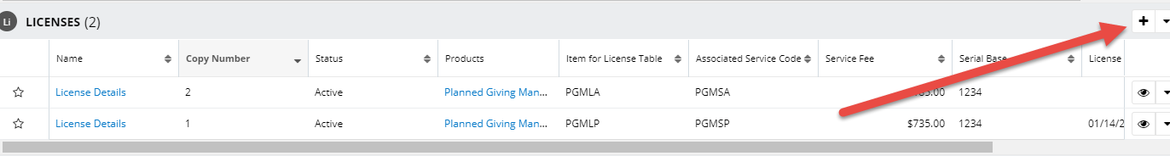
- Click the drop down to Search and Select the Organization Name
- Add the Copy Number and Service Fee
- Select PG Calc Product from the drop down
- Fill in Associated Service Code and License Code (ex. PGMLA for additional PGM license)
- Change “Status to “Active”
- Fill in Sale Date
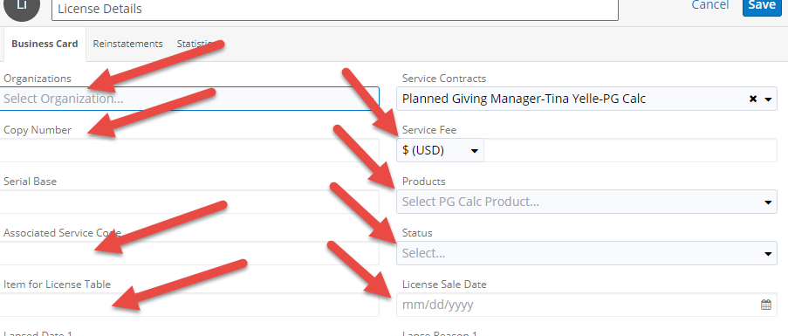
- Click save.

Making a Name Inactive

- Access the Name to make inactive (see “Search for a Name”).
- “Name Inactive Date” is located at the top right of a given Name record.
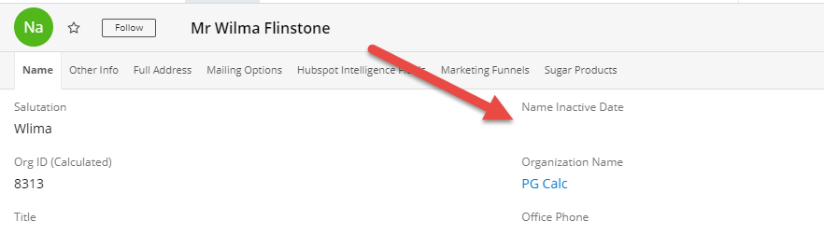

- Edit the field by clicking on “Name Inactive Date” and a calendar will appear.
- Enter the appropriate date and save.
- See “Lapsing a License” instructions if this Name was associated with a Service Contract (Service Name – User) to delete the appropriate Service Name.
- If Name is associated with any outstanding invoices, please rectify and update to new contact’s Name.

Deleting Service Name Without Making Name Inactive
- Access the given Service Contract within an Organization. Once in the Service Contract, scroll down to Service Names.
- Click into the desired Service Name Detail link on the far left.
- After confirming this is the proper Service Name to delete. Click the downward arrow next to the Edit button and then click Delete.
- If applicable, re-assign Service Name. Refer to “View and Edit a Service Contract Additional User” as a guide.
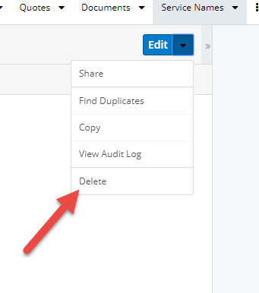

Finding a Product’s Platform
To find the Platform for a product, i.e. if a GiftWrap client is Hosted or Enterprise, in Sugar:
- Search for the given Organization
- On the given Organization page, scroll down to the Service Contracts subpanel
- Click on the far-left link to access the given Service Contract
- Within the Service Contract, scroll down to Licenses (directly below the Service Contract record)
- The Platform is listed to the far right (you may need to scroll to the right under the Licenses list view)
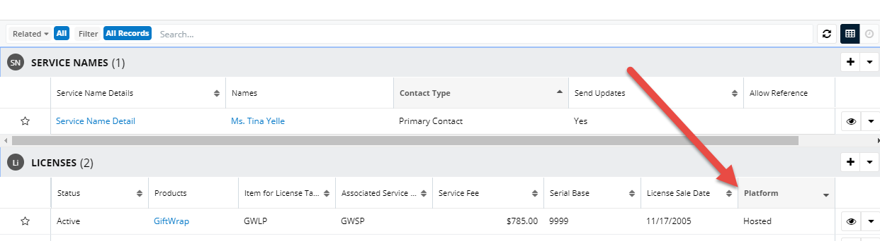

MIS Issue Tracking

When you go to the “Bugs” module you will see a screen similar to the one below. You can set a filter to see all the MIS issues or just the issues you reported. To see just your issues please select the filter (top left) and select “My Bugs”. The screen will refresh to show only your items and going forward every time you visit this page that filter will be in place until you turn it off.
If you want to see the detail simply click on the link in the “Subject” column and the detail screen will be displayed, or click the eye icon and the record will be displayed on the right. You can also click the downward facing triangle icon and select edit and edit the record from the grid.
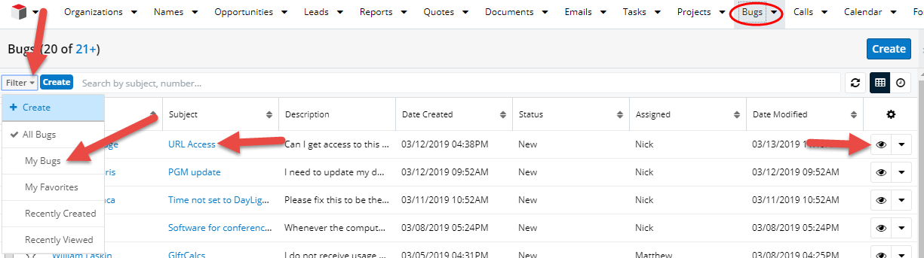
Creating a new Issue record
To create a new item for MIS, go to the “Bugs” module and click “Create”, a screen like the one below will come up. Simply fill in the subject and description fields. You can change any of the other items and click “Save”. When the case is created MIS gets a notification that there is a new bug. When the item is resolved an email will be sent letting you know it is complete.
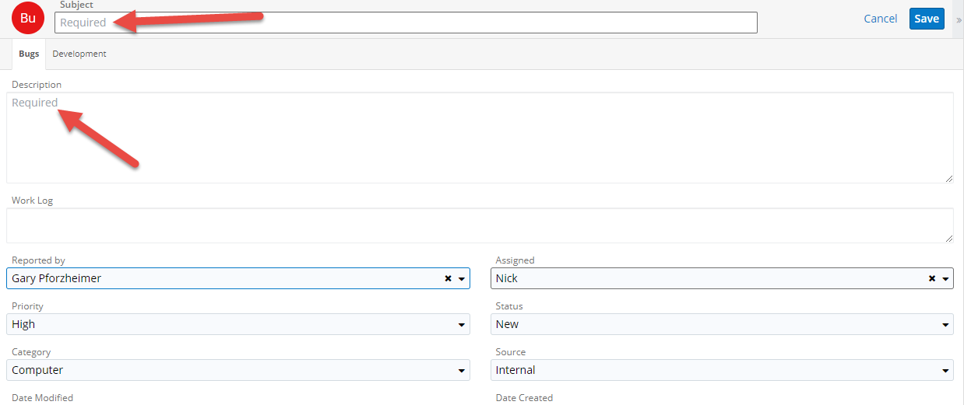
Please call MIS for email and network account lock outs and password resets.

Creating an Invoice (Quote)

Please note:
- INVOICES FOR LICENSE REINSTATEMENTS AND ADDING ADDITIONAL LICENSE COPIES SHOULD BE SEPARATE FROM ANNUAL RENEWAL INVOICES.
- When creating invoices for PGM reinstatements, both the reinstatement fee and service fee are coded using PGMSR. You can have them on separate lines on the invoice but use the same code for both.
- Please confirm payment terms prior to sending invoice. Will the software be sent upon receipt of payment or shipped in advance of payment? Please make sure to indicate this on the invoice in the Invoice Notes.
As when adding a Call, Invoices/Quotes are added at the Name level. You are starting from the Name record that has requested an invoice.
Start from the Name screen to whom the bill will be sent or for whom the services were provided.
Scroll down to the Quotes subpanel. Click the + to create an invoice.
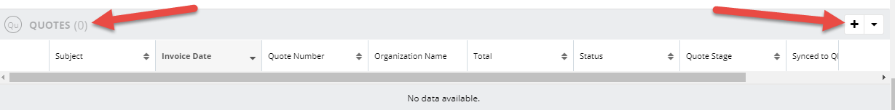

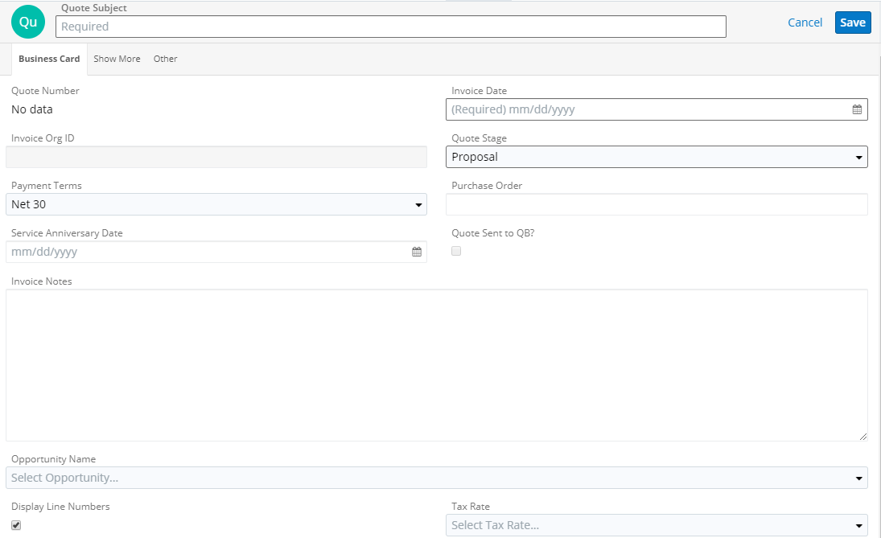
On the “Business Card” tab, fill in the following fields:
  - Quote Subject – This is the link into the Quote record. It is recommended to enter the product/service fulfilled. This field is also the default file name when downloading a PDF of the invoice. Example: PGM Additional Copy Invoice
  - Quote Stage – “Closed Accepted” if money is due to us (EX: reports, training, software sent in advance of payment). “Proposal” if software sent upon receipt of payment. See Quotes Stages and Payment Terms section for additional information
  - Purchase Order – If applicable, complete only if provided by client and requested on invoice
  - Payment Terms – select from dropdown menu as follows (Please see Quotes Stages and Payment Terms section for additional information):
    - “Due on receipt” for software sent in advance of payment
    - “Net 30” for other “Closed Accepted” stage transactions
    - “Product sent upon payment” for “Proposal” stage
    - “Payment is due by Service Date” is used for the creation of the monthly service renewal invoices
  - Invoice Notes – If applicable, i.e.“Software shipped to G. Pforzheimer in advance of payment on 01/08/15”
  - Invoice Date – typically today’s date
  - Opportunity Name – for use by Sales, not CS
  - Service Anniversary Date – this is only used for service renewal invoices.
  - Quote Sent to QB? – Do not use. This is automatically populated when Quote syncs to Quickbooks. DO NOT manually check off this box!
Click the “Show More” tab. Confirm the proper name is listed in the following fields: “Billing Organization Name”, “Shipping Organization Name”, “Billing Name Name”, and “Shipping Name Name”. *Note that the “Billing Address” and the “Shipping Address” WILL populate with information upon saving the Quote.
Skip the “Other” tab, click back to “Business Card” tab.
Scroll down to Line Items section, click the “+” to add a Quoted Line Item.
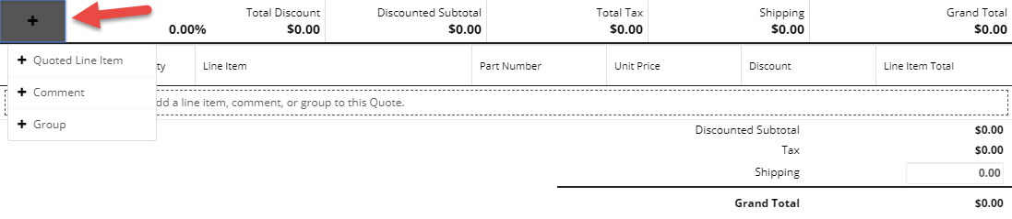
Click the “Required” field for the Quoted Line Item box.
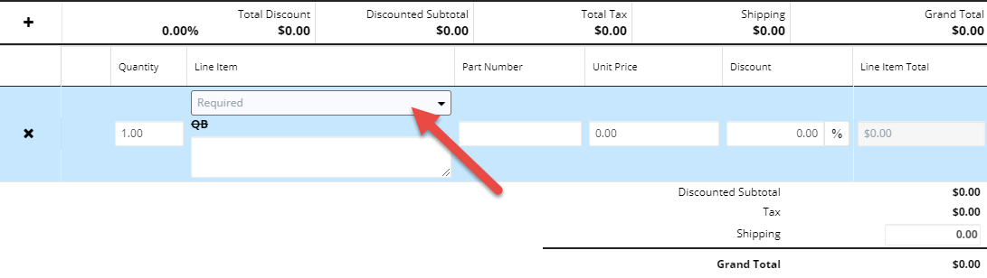
You can start typing the Product code or hit “Search and Select…” to view the PG Calc products/service table, click once on the text of the appropriate product/service.
Scroll down to see the Product Catalog List for the appropriate product.
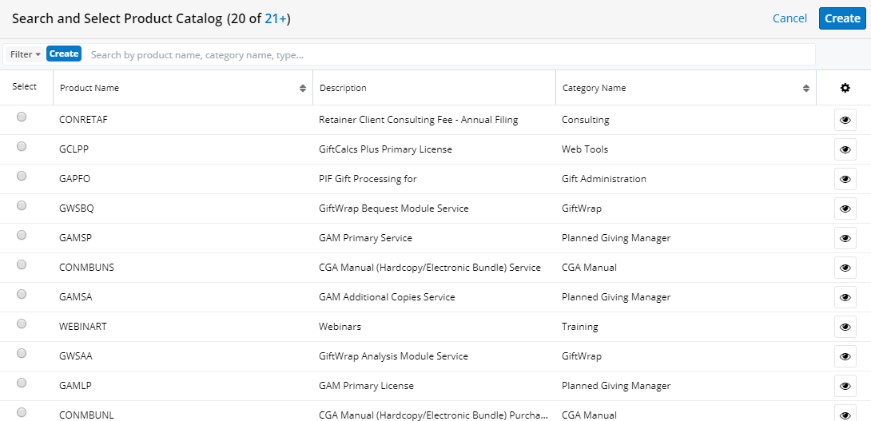

A Product Catalog will appear. Reference this complete Product Catalog when selecting the product:
Product Name | Description
ACRTI | CRT Administration Initial
AGAI | Gift Annuity Administration Initial
APFOI | Pooled Fund Administration Initial
BQMLA | Bequest Manger Additional Copy License (Stand Alone)
BQMLAA | Bequest Manager Advanced Analysis Module License
BQMLDS | Bequest Manager Document Storage Module License
BQMLP | Bequest Manager Primary License (Stand Alone)
BQMLWF | Bequest Manager Work Flow Module License
BQMSA | Bequest Manger Additional Copy Service (Stand Alone)
BQMSAA | Bequest Manager Advanced Analysis Module Service
BQMSDS | Bequest Manager Document Storage Module Service
BQMSP | Bequest Manager Primary Service (Stand Alone)
BQMSWF | Bequest Manager Workflow Module Service
CONCANMANL | Canadian Manual Purchase
CONCANMANS | Canadian Manual Service
CONMANL | CGA Manual (Hardcopy) Purchase
CONMANLA | CGA Manual (Hardcopy) Additional Copy Purchase
CONMANS | CGA Manual (Hardcopy) Service
CONMANSA | CGA Manual (Hardcopy) Additional Copy Service
CONMBUNL | CGA Manual (Hardcopy/CD Bundle) Purchase
CONMBUNLA | CGA Manual (Hardcopy/CD Bundle) Additional Copy Purchase
CONMBUNS | CGA Manual (Hardcopy/CD Bundle) Service
CONMBUNSA | CGA Manual (Hardcopy/CD Bundle) Additional Copy Service
CONMCDAL | CGA Manual (CD) Additional Copy Purchase
CONMCDAS | CGA Manual (CD) Additional Copy Service
CONMCDL | CGA Manual (CD) Purchase
CONMCDS | CGA Manual (CD) Service Fee
CONPROJ | Project Consulting
CONRET | Retainer Client Consulting Fee - December 2017 Services
CONSPEAK | Speaker Fees
CONSTATE | CGA Application Materials for [state(s)]
GAACT | Actuarial Reports
GACRT | CRT Administration Service for the period 4/1/2017 to 6/30/2017
GACRTS | CRT Administration Set Up
GAFASB | FASB Runs
GAGA | Gift Processing for CGA Gifts for the period 7/1/2017 to 9/30/2017
GAGAS | Gift Annuity Administration Set Up
GAMLA | GAM Additional Copies License
GAMLP | GAM Primary License
GAMSA | GAM Additional Copies Service
GAMSP | GAM Primary Service
GAPFO | Gift Processing for PIF Gifts for the period 4/1/2017 to 6/30/2017
GAPFOS | Pooled Fund Administration Set Up
GARES | Gift Annuity Reserves
GCC | GiftCalcs Customization
GCLIP | GiftCalcs Integration Primary License
GCLPP | GiftCalcs Plus Primary License
GCSIP | GiftCalcs Integration Primary Service
GCSPP | GiftCalcs Plus Primary Service
GCSR | GiftCalcs Reinstatement Fee
GGLIP | GiftGuide Integrated Primary License
GGLPP | GiftGuide Plus Primary License
GGSIP | GiftGuide Integrated Primary Support
GGSPP | GiftGuide Plus Primary Support
GSLIP | GiftStory Integrated Primary License
GSLPP | GiftStory Plus Primary License
GSSIP | GiftStory Integrated Primary Support
GSSPP | GiftStory Plus Primary Support
GWC | Giftwrap Customization
GWLA | GiftWrap Additional Copies License
GWLAA | GiftWrap Analysis Module License
GWLBQ | GiftWrap Bequest Manager Module License
GWLBQA | GiftWrap Bequest Manager Module Additional Copies License
GWLDS | GiftWrap Document Storage Module License
GWLEF | GiftWrap Escrow License Fee
GWLEP | GiftWrap Enterprise Version License
GWLHG | GiftWrap Gold Hosted License
GWLHP | GiftWrap Platinum Hosted License Fee
GWLHS | GiftWrap Silver Hosted License
GWLP | GiftWrap Primary License
GWLPF | GiftWrap Pooled Fund Module License
GWLPFA | GiftWrap Pooled Fund Module Additional Copies License
GWLRG | GiftWrap Registered Copies License
GWLRM | GiftWrap Remote Copies License
GWLTC | GiftWrap Tax and Check Module
GWLTF | GiftWrap License for Two Factor Authentication
GWLWF | GiftWrap Work Flow Module License
GWLWS | GiftWrap Web Services Module License
GWSA | GiftWrap Additional Copies Service
GWSAA | GiftWrap Analysis Module Service
GWSBQ | GiftWrap Bequest Module Service
GWSBQA | GiftWrap Bequest Manager Module Additional Copies Service
GWSDS | GiftWrap Document Storage Module Service
GWSEF | GiftWrap Escrow Service Fee
GWSEP | GiftWrap Enterprise Version
GWSHG | GiftWrap Gold Hosted Service
GWSHP | GiftWrap Platinum Hosted Service Fee
GWSHS | GiftWrap Silver Hosted Service
GWSP | GiftWrap Primary Service
GWSPF | GiftWrap Pooled Fund Module Service
GWSPFA | GiftWrap Pooled Fund Module Additional Copies Service
GWSR | GiftWrap Reinstatement Fee
GWSRG | GiftWrap Register Copies service
GWSRM | GiftWrap Remote Copies Service
GWSTC | GiftWrap Tax and Check Module
GWSTF | GiftWrap Service for Two Factor Authentication
GWSWF | GiftWrap Workflow Module Service
GWSWS | GiftWrap Web Services Module Service
GWTG | GiftWrap Group Training
GWTI | GW Individual Training
MMLA | Mini Manager Additional Copies License
MMLP | Mini Manager Primary License
MMSA | Mini Manager Additional Copies Service
MMSP | Mini Manager Primary Service
MSDMB | Marketing Services Direct Mail Brochure
MSDMM | Marketing Services Direct Mail Mailers
MSDMN | Marketing Services Direct Mail Newsletter
MSDMO | Marketing Services Direct Mail
MSEMC | Marketing Services Email Targeted Emails
MSEMN | Marketing Services Email Newsletter
MSEMS | Marketing Services Email Measured Mail
MSPADV | Marketing Services Advanced Package
MSPAG | Marketing Services All Gift Package
MSPAGP | Marketing Services All Gift Plus Package
MSPBQ | Marketing Services Bequest Package
MSPC | Marketing Services Custom Package
MSPS | Package Set Up Fee
MSPSO | Marketing Services Site Only Package
MSSA | Marketing Services Strategy & Analysis
OREIM | Reimbursements
PGMC | PGM Customization
PGMLA | PGM Additional Copies Licenses
PGMLP | PGM Primary License
PGMLUG | PGM Upgrade
PGMR | PGM Runs
PGMSA | PGM Additional Copies Service
PGMSP | PGM Primary Service
PGMSR | PGM Reinstatement Fee
PGMSU | PGM Service Upgrade
PGMTG | PGM Group Training
PGMTI | PGM Individual Training
PREIM | Reimbursements for Consulting
RBATCH | BatchCalcs
USALA | USA Additional Copy License
USALP | USA Primary License
USASA | USA Additional Copy Service
USASP | USA Primary Service
WEBINART | Webinars

Double-click on the appropriate product name field. (***Clicking once will populate the appropriate product, but you will have to click the blue “Cancel” in the top right to return to the invoice. Double-clicking selects the appropriate product and returns you to the Quote screen.) (This is a known Sugar bug and has been reported 03/19 AJL). Please ask MBH or AJL if you have any questions regarding which Name to select).
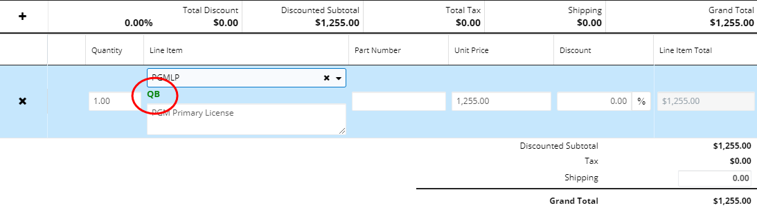
You will know if you have selected the correct product code when the “QB” turns green to sync with QuickBooks. It will remain as “QB” if not synced properly.
When typing in the product code DO NOT select the lowercase option listed. This will not sync with QB.
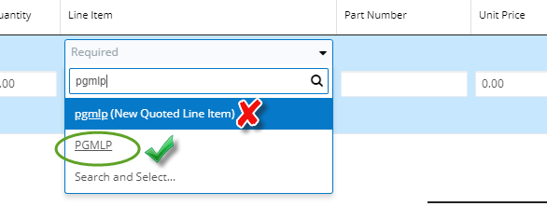
Notice with each field that populates, the Quantity defaults to 1, depending on the Product selected. The Unit Price may populate with a value, but usually is 0.00. If 0.00, you must manually enter the Unit Price. You may also update any default value that populates in this field. Also, you may adjust the Quantity as needed and the subtotal will update automatically. **Please do not edit the Quoted Line Item code as this product code will be logged appropriately.
Update the description below the Quoted Line Item as appropriate – this will appear on the printed invoice. Once the Quoted Line Item is complete, click Save (blue button) at the top right of the Quote.
If you need to adjust the Quote’s Business Card after saving, click the blue Edit button in the top right of the Quote. Once it is updated click Save.

If you need to adjust one of the Quoted Line Items, click on the three dots to the left of the item’s quantity and click Edit or Delete.
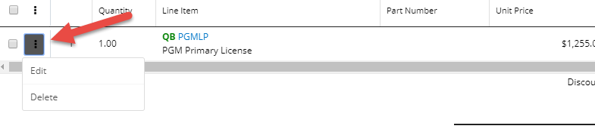
When finished editing click the checkmark in the blue circle to Save.
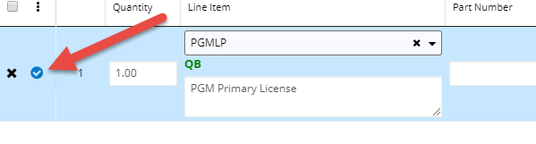
Please note, if you click the blue Edit button in the top right of the Quote and then edit a quoted line item, you will receive the following message if you do not click the blue checkmark before clicking the blue Save button in the top right of the Quote screen.
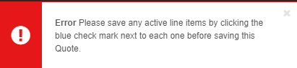

To group Quoted Line items check the grey boxes of the Line Items you would like to group, then click the 3 dots above. You can then click Group Selected.
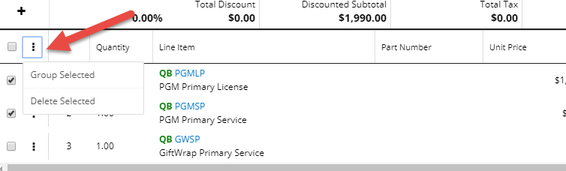

A group field will appear where you can type in your desired group name.
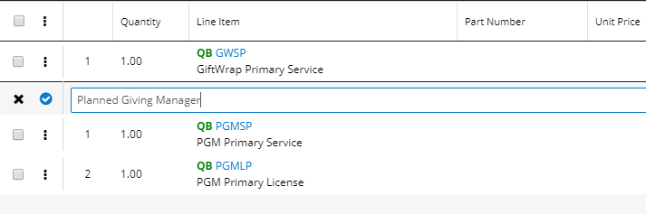
You can repeat those same steps to group other item(s) and designate a group name.
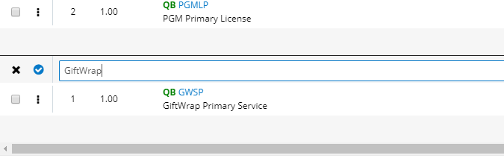
Click the blue checkmark to the left of the group name to save.
Click the down arrow next to the Edit button in the top right of your Quote.
Under “Download PDF” you have several options, including downloading just the invoice.
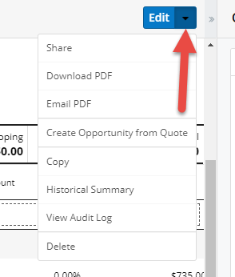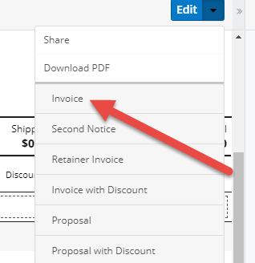

Click Invoice under Download PDF and the Quote will download to your web browser, open and save accordingly.
**Please note that invoices no longer need to be printed and handed-off to F & A, UNLESS YOU ARE REVISING AN ANNUAL RENEWAL INVOICE, PLEASE NOTIFY RG.
**Use code PGMSR for ALL PGM License and Service Reinstatements.
Please pay special care to the Payment Terms.

Processing credit card orders for new/reinstated software orders (not renewals):

1) Take credit card payment or refer client to the link on our website to pay online
2) Check in Sugar to see if there is already a Quote/Invoice for this order – If so, please reference this Invoice Number on the credit card payment form
3) If no Invoice is in Sugar, please create a new Invoice in Sugar for this order

For the Quote Stage, please mark it as Closed Accepted and for payment terms, you can just leave it as the default of Net 30 (Payment terms don’t really apply since they have already paid but this field does need to have something). Per DK

Editing an Existing Invoice

- Search for Invoice’s Organization
- Scroll down to the Quotes subpanel under the specific Organization
- Choose the desired invoice by clicking the Quote Subject hyperlink on the far left
(Note that renewal invoices contain the Quote Subject “Quote for <Organization>”)
- Click the Edit button in the top right to edit the Business Card or Show More tabs or click the three dots to the left of the quoted line item or group you wish to edit
- Revise accordingly based on circumstance:
    - Edit Quantity by revising the numerical value in the Quantity box (within Line Items)
    - Remove an entire Line Item row by clicking the three dots and selecting Delete
    - Revise an Address/Name by clicking into the Show More tab (top left) and updating accordingly
- Click the blue checkmarks to Save individual quoted line items or Save in the top right to save entire quote.

**If you are adjusting a RENEWAL INVOICE, you need to notify F&A/RG of any changes

- To download a PDF of this invoice, click the downward arrow next to the Edit button
- Email revised invoice (PDF) to desired party
- Log Call under the Name you are sending the invoice to, noting the revised invoice details
- If revising number of Licenses for any product (i.e. adding, reinstating, or lapsing), please update or refer via email to MBH/AJL to update accordingly
- If revising a one-off invoice, even if changing the payment terms, F & A does not need to be notified. They will be able to refer to this change in Sugar.

Create All Documents for Renewal Invoices

Take note of the Renewal Invoice number and click the Quotes tab.
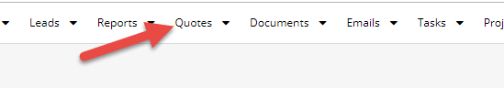

Find your Quote. This is easiest to do if you set up a Quote Number filter pictured below.
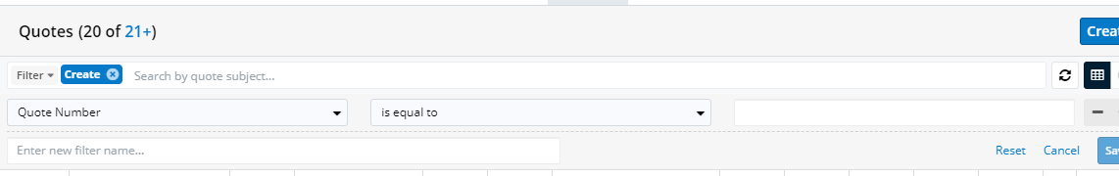
Once you locate your Quote, click on the radio button to the left of the Quote Subject. Then click the download arrow to the left of the Subject field.
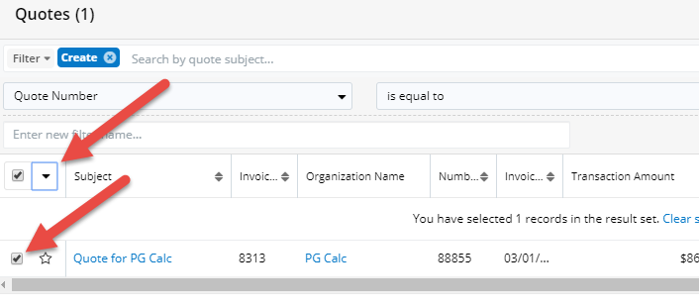
Then select “Create All Documents”
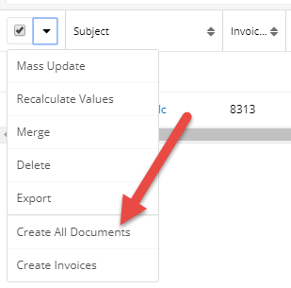
It may take a moment, but a PDF will be generated showing a Renewal Letter from GMP, the Renewal Invoice, and a Service Names Report for Products and Services. One or all of these pages can be sent to the client. If any of the Service Names are edited, the Service Names Report will update upon a new download by repeating the same steps above.

Quote Stages and Payment Terms

Quote stages and terms
Situation | Quote Stage | Payment Terms | Invoice Notes: (enter manually, no pick list)
Waiting for payment before filling order | Proposal | Software will be shipped upon receipt of payment | License for “Name” if applicable
Order filled, software shipped in advance of payment | Closed Accepted | Due on receipt | Software shipped in advance of payment to X on X.
Existing client overdue renewal, update not shipped | Closed Accepted | Payment is due by Service Anniversary Date | N/A
Existing client overdue renewal, update shipped | Closed Accepted | Due on receipt (*would be manually changed from Payment is due by Service Anniversary Date) | Software shipped in advance of renewal payment to X on X.
Existing client renewal | Closed Accepted | Payment is due by Service Anniversary Date | DCK would use batch-quote generator if a renewal invoice was generated in advance of F & O timeframe.
Client has lapsed service, renewal invoice already sent | Lapsed Service | Payment is due by Service Anniversary Date | When is this used? Quote Stage manually changed by CS when a client has lapsed.

Adding an IT Contact to a Service Contract

We now can add an IT contact as a Name associated with a Service Contract. This IT contact does not have to be a license holder of the software.
- Go to your desired Organization
- Scroll down to access your desired Service Contract (EX: Planned Giving Manager) in the Service Contracts subpanel of the given Organization
- Click on the far-left hyperlink (Name column) to access the proper Service Contract
- Within the Service Contract, scroll down to the Service Names subpanel and click “+” on the far right

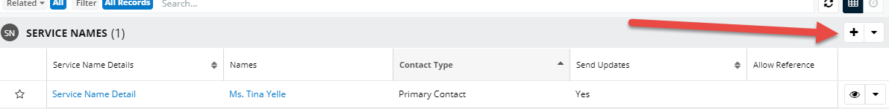

- The Service Name “Name” and “Service Contracts” will auto-populate, you do not need to fill in this information
- Under “Names,” click “Select name” and “Search and Select…”
- You will now be able to search for the desired IT contact Name
- Click the “Select” radio button on the far left to select your desired Name, you will be brought back to the Service Name record
- Click “Select Organization” and “Search and Select…” to enter the proper Organization name, you may try to enter the Organization name in the text box prior to “Search and Select…” but please click “Search and Select…” if you see duplicates to confirm you are selecting the proper Organization
- Click “Select” under Contact Type, and select “IT Contact”

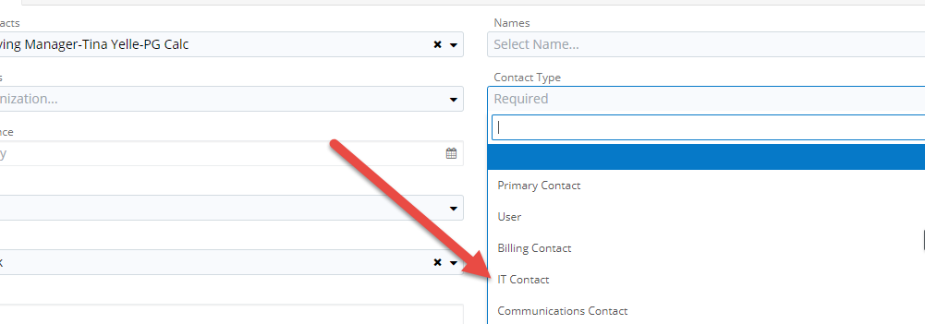
- Click the blue Save button in the top right, you do not need to enter any more information, you will be brought back to the Service Contract record
**An IT contact may request that NO software updates be sent to license holders. If approved by the primary contact, edit the “Send Updates” field within each Service Name detail and set to No
**ALSO make a note in the org description
Example: ***PGM updates to primary contact Ryan Repp and IT contact ONLY. All users should have "send updates" set to "no." (5/18, mbh)***

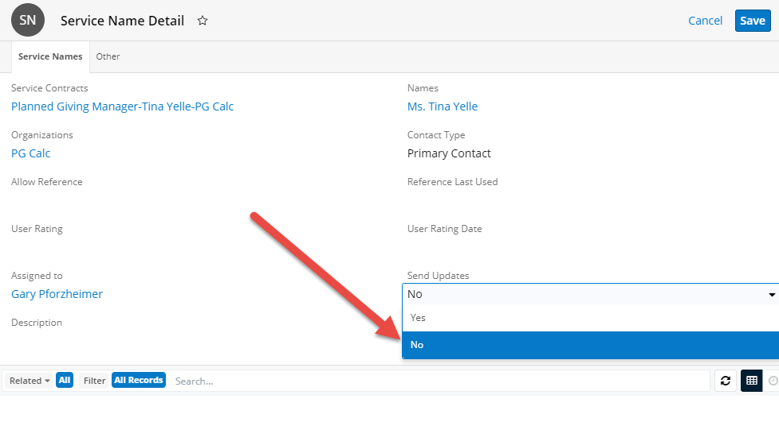

Updating Outlook Password

When you update your Microsoft Outlook password you MUST update your password in Sugar in order to send emails. Click on the person icon located in the top right of your Sugar screen, then click Profile.

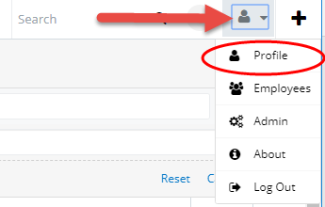
Click the Edit button
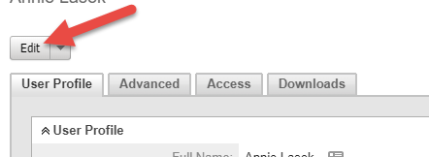
Scroll down to the Email Settings section and click “Change Password”
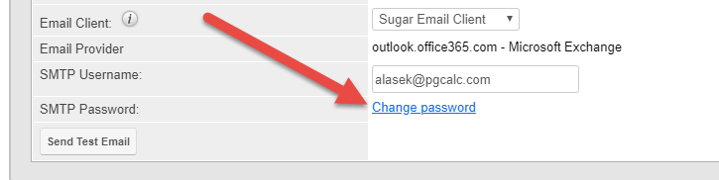
Type in your new password and then click Save

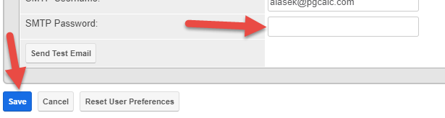

Editing and Creating an Email Signature

- Locate the Emails tab and click on the downward arrow to the right of Email

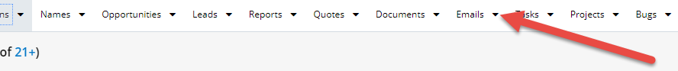

- Click “View Email Signatures” in the dropdown menu

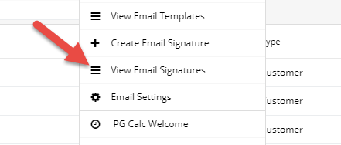

- Edit Signature accordingly with standard Font Family Arial > Save
- To create an email signature, click “Create Email Signature” from the dropdown menu

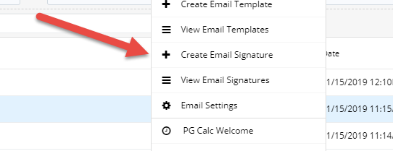
- Edit Signature accordingly with standard Font Family Arial > Save

Sending and Creating an Email Template

- To send an email template, locate the Name record for the email recipient
- Click on the email address link within the Name record
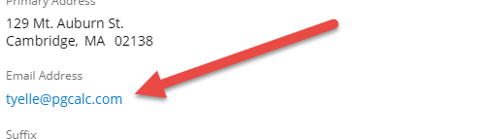

- The Compose Email screen will appear. Click on the small paper icon to view Email Templates
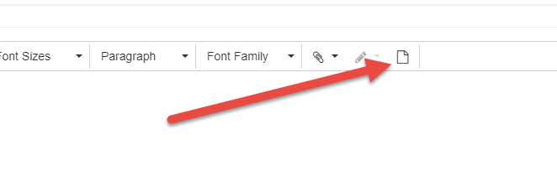
- Locate email template to be used and select the radio button. A Warning message will appear, click Confirm

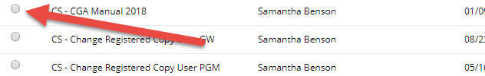

- Review the message before sending. Note any values not calculated and edit. Ex. For new primary contact “Welcome” emails, enter the appropriate Service Anniversary Date
Notes
- You can view your emails by clicking the downward arrow to the right of Emails and clicking “View Emails”
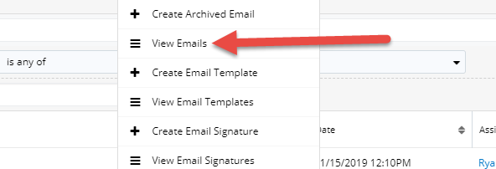
You can filter emails by “Assigned To”, “Subject”, “Date”, etc.
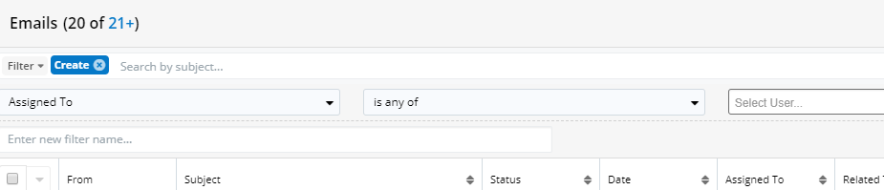
Emails sent through Sugar will show up in your Outlook Sent folder
To create an Email Template, click on the download arrow to the right of the Emails tab, then click Create Email Template
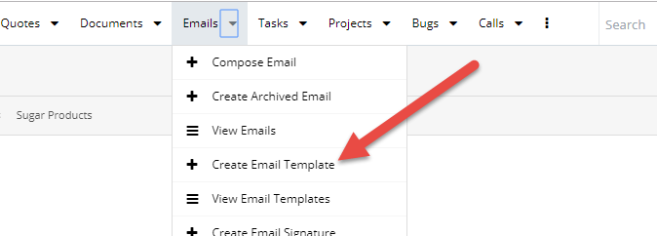
A Create screen will appear where you can fill in the necessary information. The Name and Description fields are for internal purposes whereas the Subject and Body are intended for the client

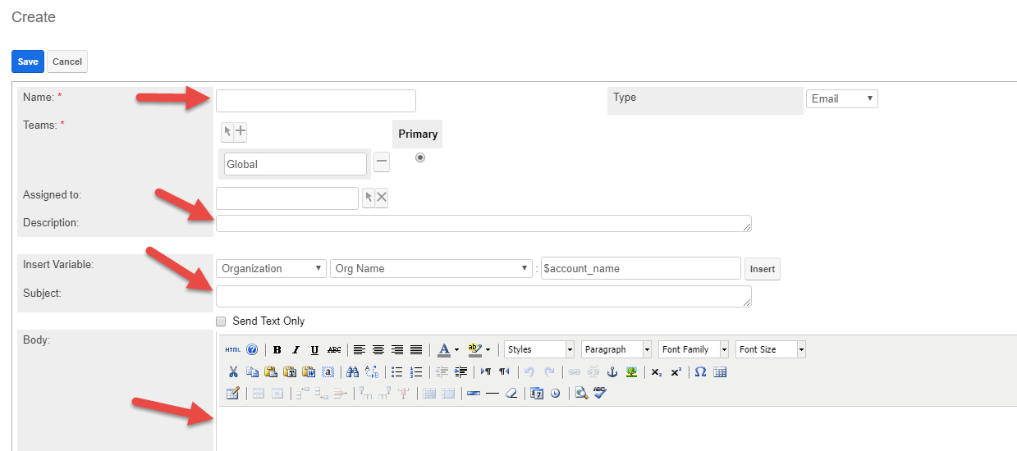

Type your email into the Body field. You can insert variables into the text to auto populate information from the organization. For example, inserting Organization > Org Name would insert the Organization to which the email recipient is associated with upon sending. Click Save

It is best practice to send yourself a few test emails to review its display before sending to a client.

A File or Sugar Document can be attached to an Email Template by scrolling down to the bottom of the Body field and selecting Choose File. You will then be prompted to select the desired file

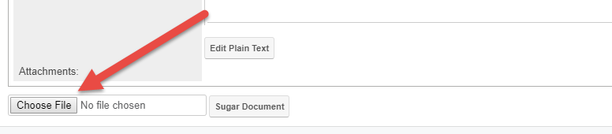

Merging Organizations

1) Search for the desired Organizations to merge in the Organizations Search screen. You can merge up to 5 records at one time. Open each Organization record in a new tab for later review by right-clicking each Organization hyperlink.

2) In the Organization Search screen, select the appropriate checkboxes to the left of the Organization names and Org IDs.

**IMPORTANT – Select FIRST the Org that will become the PRIMARY organization. This will ensure the listed OID AND the URL OID will match

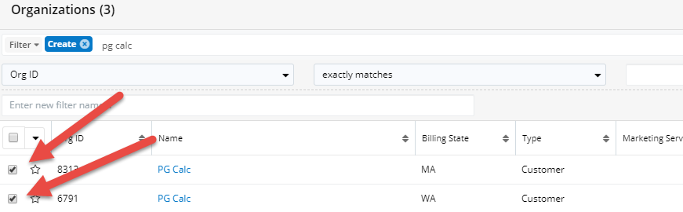

Then, select the downward arrow above the checkboxes to open a menu. Select Merge.

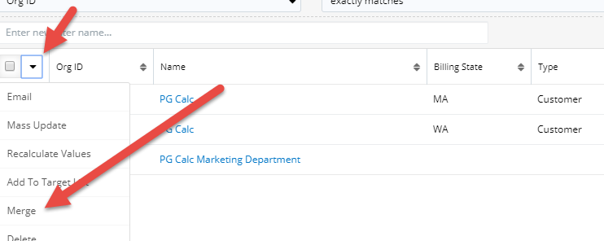

The master Organization record (Primary and selected first) will appear on the left and is the Organization the other Organization will merge into. You want to keep the radio buttons selected for the appropriate Primary Organization record on the left as this will be the Organization information moving forward after the merge. It should be obvious which Organization is the Primary but please let the Sugar team know if you have any questions. See image on the next page for reference. Click Save in the top right.

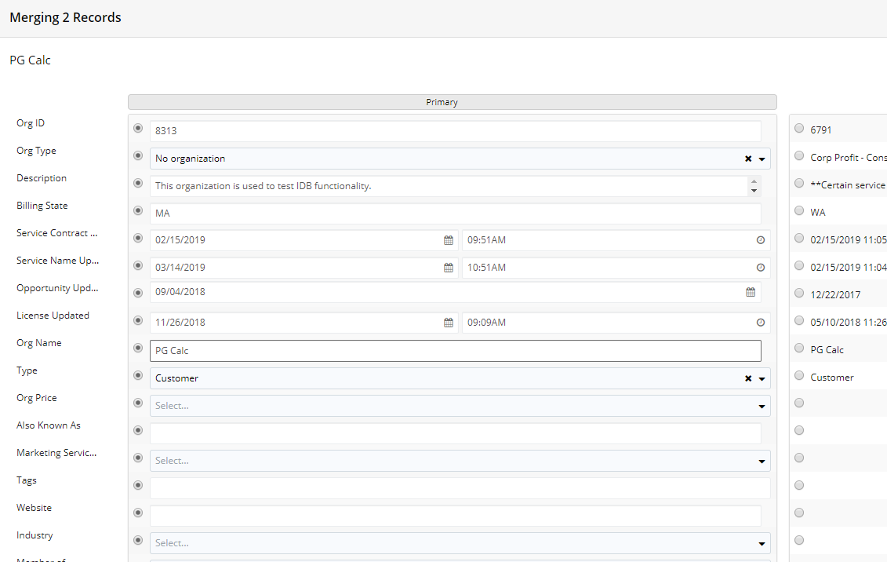

After merging, review all the subpanel data in the two “pre-merged” Organizations (in separate tabs) and confirm all the data is included in the newly merged Organization record. Recommend reviewing the first 5 entries for larger subpanels such as Names and Calls.

Merging Names

1) Search for the desired Names to merge in the Names Search screen. You can merge up to 5 records at one time. Open each Name record in a new tab for later review by right-clicking each Name hyperlink.

2) In the Name Search screen, select the appropriate checkboxes to the left of the Names.

**IMPORTANT – Select FIRST the Name that will become the PRIMARY Name. This will ensure the listed Name ID AND the URL Name ID will match

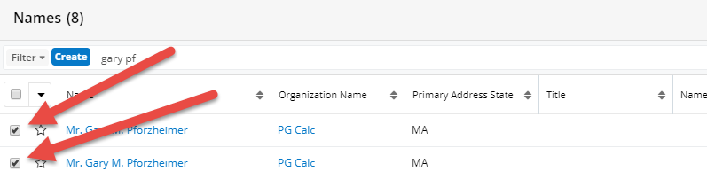
Then, select the downward arrow above the checkboxes to open a menu. Select Merge.

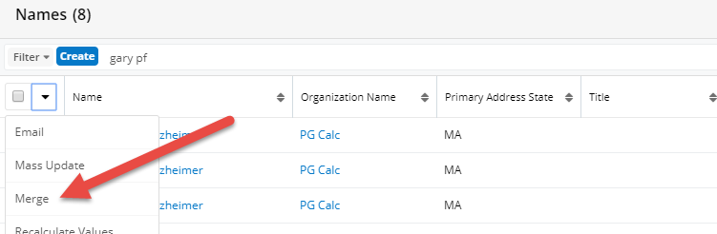

The master Name record (Primary and selected first) will appear on the left and is the Name the other Name will merge into. You want to keep the radio buttons selected for the appropriate Primary Name record on the left as this will be the Name information moving forward after the merge. It should be obvious which Name is the Primary but please let the Sugar team know if you have any questions. See image below for reference. Click Save in the top right.

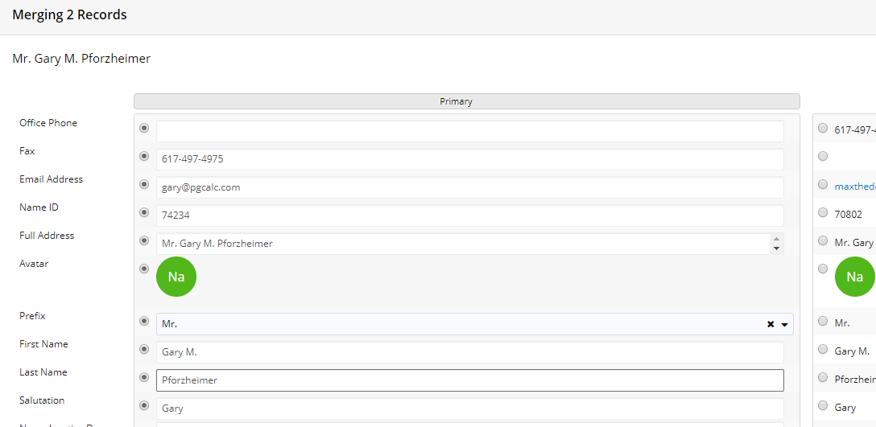

After merging, review all the subpanel data in the two “pre-merged” Names (in separate tabs) and confirm all the data is included in the newly merged Name record. Recommend reviewing the first 5 entries for larger subpanels such as Calls and Emails.

Create an Organization

You will need to start at the “Organizations” tab.
BEFORE creating an organization, you should verify the organization does not already exist. Check that it is not under an acronym, use the wildcard % in case there is an article you did not count on. You only want to create an organization if it does not exist somewhere else.
Tip: If you are creating an organization because you need to add a person to said organization, do a global search for the second part of their email address (i.e. pgcalc.com)—it may bring up people/organizations that did not work in the general search.
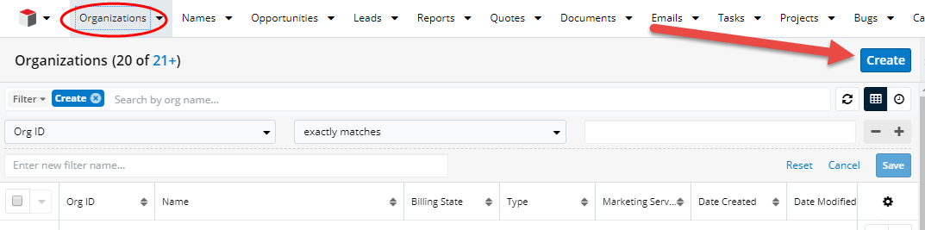
If you have clearly verified that the organization does NOT exist in sugar, press the blue “Create” button at the top right of the screen.
The first thing you will need is the Organization Name. We want the legal name if possible, so please make sure you have the real, full Name. Pay attention to acronyms and any spaces (i.e. should it be “Human Good” or “HumanGood”; should it be “MFA” or “Museum of Fine Arts”?)
**Org Name must be less than 40 characters. Quotation marks, apostrophes, ampersands, and certain other special characters count as 4+ characters each.

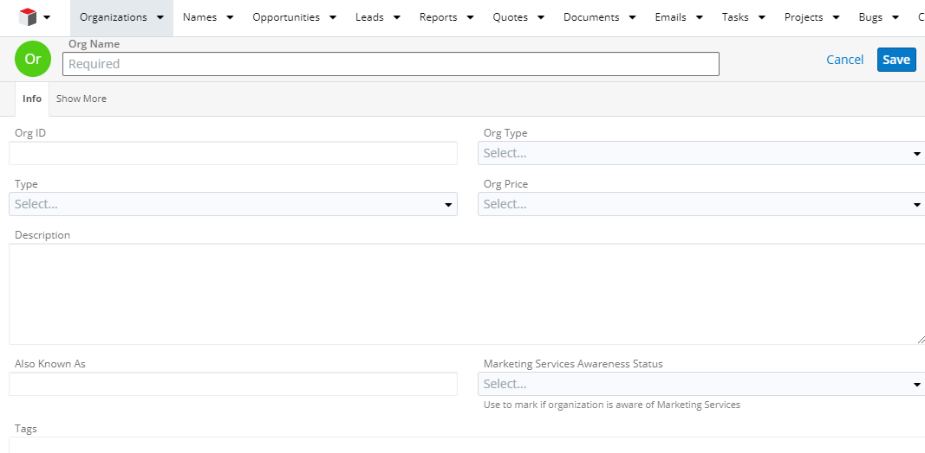
You do not need to fill in the “Org ID”, but “Org Type” is useful and usually relatively apparent. “Type” should be marked as “Customer” as this is required to sync with QuickBooks. “Org Price” can be left empty unless you know there is something a special exception. The free text “Description” can be used for putting in information that might be useful. The “Also Known As” section is a place for that MFA vs. Museum of Fine Arts dichotomy to be acknowledged.
Click the “Show More” tab at the top to enter the Organization’s Billing State. You can also enter the website of the org, which is useful. The rest can be left blank.

Linking Calls to a Name Record

Calls should be logged at the NAME record level. Sometimes you make a mistake—you put a call under the Organization, or worse, under the Opportunity.
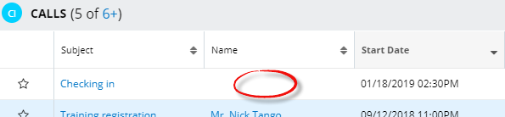
Rather than deleting it and logging the call again, or ignoring it completely, you can still link the call to a Name record!

First, make a note of the Call Subject. Then find the Name record you wish to link the call to, then within the Calls subpanel locate the downward arrow to the right of the + symbol. Click the arrow then click “Link Existing Record”.

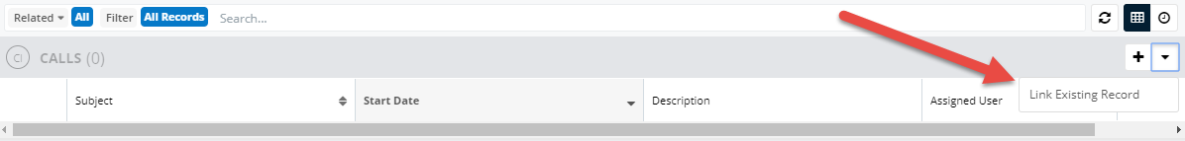

Locate your logged Call from the list. It will most likely be towards the top of the list depending on how many calls have been logged since. Check the box to the left of the Call and then click “Add” in the top right of the screen

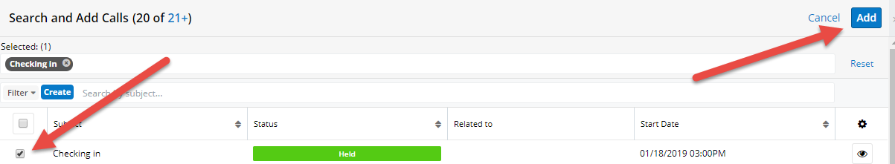

If your Call is not at the top, you can search by what you put in the subject or use the filters on the left.
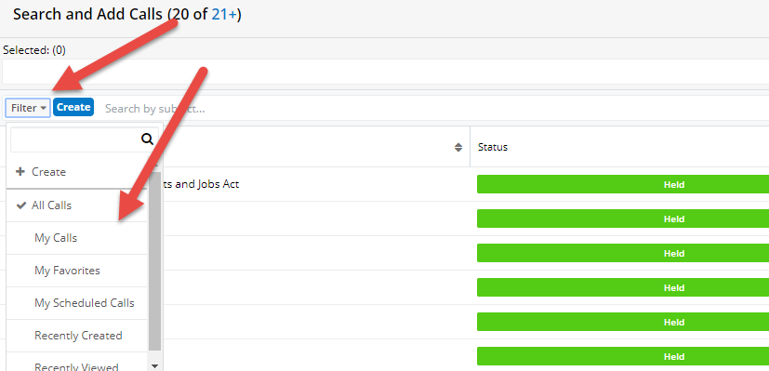

Calls should now show the Name associated with the call you just logged. If you made the call under an opportunity, it will need to be linked, using the same process starting with the Organization, to the Organization as well as the Name. Opportunities follow the exact same process as Calls with one important difference. When you are in the Name record, instead of pressing the arrow next to “Calls”, you press the arrow next to “Opportunities.” Proceed as usual.

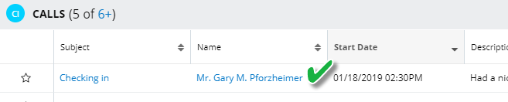

Link Existing Records

- Go to the appropriate person. As annoying as it is, you cannot link from the Opportunity to the Name, just from the Name to the Opportunity.
- Scroll down to the Opportunities section, and press the down arrow button next to the plus sign

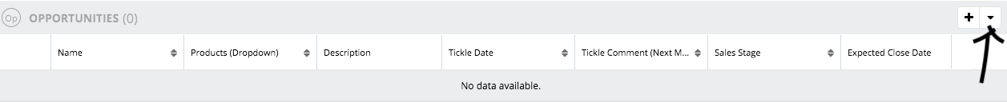

- Click “Link Existing Record”

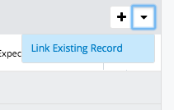
- This will take you to the “Search and Add Opportunities” page. This will have a list of all opportunities, so unless you just made/edited it, you will likely need to search. Fortunately, all Opportunities are named for the Organization they are with, so you can just type that in. In the cases where they have many Opportunities, general reminder: Consulting is PCID9 and State Registration is PCID10. (Found in the Name of the Opportunity, i.e. Freestore Foodbank-PCID9).
.
- When you find the appropriate Opportunity, click the square to the left of the Opportunity name.

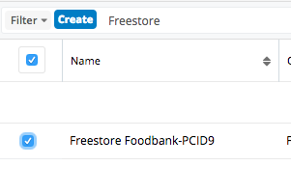

- Click the “Add” button at the top right of the screen
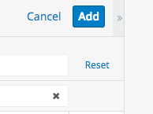

- This screen will appear, followed by reverting to the Name record, now with Opportunity attached. You’ve done it!
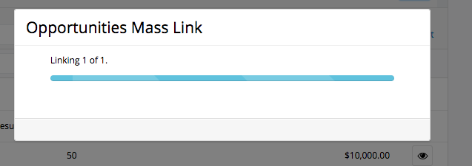

Sales Forms for Sugar

Call Fields
When to log a call: When there is contact that you think would be interesting/useful either to yourself or your colleagues at a future date.
- One call per incident, even if it takes one or two call-backs to have the discussion.
- Log all follow up action in one call record (e.g. sent a demo, sent rate sheet/proposal, etc.).
- Create one call record for multiple products unless there is very different information about each.

Where to log information: In the name record for the prospect (Organization>Name>Call).

Subject (up at the top, easy to miss): A brief synopsis, i.e. BatchCalcs: GR left a VM. The name of the product isn’t necessary because that’s another data field, but it’s helpful.

Start Date, Time, End Date, Time: Auto-populates; change start time as need be, ignore end time.

Related to: Should auto-populate with the appropriate organization.

Contact Duration (Minutes): Estimate the amount of time on the call.
- 1 min for no VM, 2 min for VM, etc.
- The time it takes to compose an e-mail

Contact Type: How you spoke with them. Use “Other” for face-to-face interactions.

Description: what went on in the call/conversation/meeting etc.
- If a phone call, write your phone notes as completely as you have them. If an e-mail message, it’s fine to copy and paste your email exchange into the field. The more detail the better.

Contact Product: Which product the call was associated with, i.e. Planned Giving Manager

Direction: Who gets credit for reaching out
- This is based on initiation. If you call and leave a VM and the prospect calls you back, it’s outbound. If the prospect initially calls, even if you then call them back, it’s inbound.

Assigned to: The person who took the call
- If you are logging the call for another person (s)he will get an e-mail based on our workflows.

Contact Category: Use sales unless the nature of the call was something service related.

Opportunity Fields
When to create an opportunity: When follow up by PG Calc is expected, within 1 year.

Where to log information: Under the point prospect’s name (Organization>Name>Opportunity).

Opportunity Name & Organization Name: Should auto populate. Don’t try to edit it.

Expected Close Date: When you think every part of the sale will be closed. This date is used for pipeline analysis but will change during the sales process. It should always be after the Tickle Date. When the sale closes, the date should be changed to the current date.

Description: The specific details of the opportunity. This is a description of what the client needs and the specific products/services defined in our own language and including atypical pricing. Pls. include the following when applicable:
- Price (including discount) if quoted
- Software: date when trial was issued and how many copies of the software are needed
- Marketing: what the scope is of what we’re trying to sell
- Gift Admin: what gift types/how many (e.g. CGAS, CRT, PIF), if they need ACH and which bank has the assets
- State Registration: which states
- Project or Retainer Consulting: description of need

Product: This is a drop down of products we have, with some broader categories. Go with the correct category even if it isn’t the exact product (PGM mini is PGM).

Tickle Date: The date when you need to act. This will appear in your Tickle Report and is typically around 2 weeks out.

Sales Stage: Adjust as the sale moves along
- Qualification: initial stage (the default). Very little contact, once qualified, the opportunity moves on or may be closed.
- Persuasion: you’re talking with your prospect but have not moved them further yet.
- Demo: you’ve sent them something (for software this is typically an eval, for Admin, MS and Consulting it’s a long call with the interested parties).
- Proposal: you’ve sent them a proposal or a rate sheet. You stay at this stage until you have asked for the sale. If they aren’t ready to proceed, then they stay at this stage with an appropriate tickle of less than a year. If the ask is unsuccessful, it should be considered closed/lost or closed/not now.
- Agreement: proposal has been accepted and it is time to get documents returned and the client invoiced. The next step from here is closed unless something happens such as a change of personnel on their end, or a change of heart, or a long delay.
- Closed Won: congratulations, we got their business.
- Closed Lost: The opportunity has closed, they chose to go with a competitor or do it themselves.
- Closed Not Now: Any other loss, whether it was because the person we were working with moved to a new location, if they’ve decided to try and do it themselves, etc.
- Closed Missed: the sale was missed through a fault of our own, usually by not keeping track of tickle dates and not following up.

Tickle Comment: The next course of action, your refresher for what to do next.
- “Call for more information.” “Follow up on trial.” “Ask DAW about status.” Etc.

Likely $: Enter the closest ballpark amount specific to that product, i.e. PGM with an additional copy: $2,575. Remember what’s in the description, including atypical pricing. The probability of winning this opportunity does not affect Likely $, it is the likely amount of the actual invoice.

Probability: This is the measure of how likely we are to win the sale. This is very important, it’s okay if you guess, and it should change as the sale progresses, increasing or decreasing after a demo or proposal. Probability should never be 100% and when you don’t know, use an average for the product. Below 10% means you have no idea and are waiting for more information, as may be appropriate for a freshly created opportunity awaiting the first conversation. This does not change the likely $.

Lead Source Category/Lead Source: How did the prospect hear about PG Calc? These are crucial fields—be thoughtful with your entry. Please use the “other” sparingly and elaborate in Lead Source Detail.
- Marketing: they got a postcard, an email, or something else that directed them to us.
  - Conference
  - Direct Marketing
  - HubSpot Request (typically from the website, keep an eye out if they were directed to HubSpot by DM)
  - Website
  - Inbound Call/Email: Based on who initiated the action.
  - Other
- Prospecting: cold calls
  - Outbound Call
  - Outbound Email
  - Turned Conversation
- Referral: Someone told them about us
  - Internal
  - External

Lead Source Detail: This is free text and can help with future analysis or thank yous (e.g. which conference, who made the referral, which direct marketing piece).

Partner Organization: Used sparingly, and typically for a referring financial services firm for a charity considering admin, or sometimes for communications companies with whom we partner for GiftCalcs.

Customer Type: This dropdown has four entries
- Client of this Product (Reinstating or Upgrading): This is used for upgrading (i.e. Gift Admin for CGAs are adding PIF), GiftCalcs considering Marketing Services, GAM looking at PGM, and reinstatements.
- Client Organization: Adding a new line of business to an existing customer, e.g. marketing services for a PGM client.
- Prospect Organization: If the organization exists but hasn’t bought anything from us.
- New Organization: If you just setup an organization to make this opportunity.

Assigned to: Generally, this is the person who is responsible for the follow up. If you set up an opportunity for someone else, or change the assignment at any time, an email will be generated and sent to that person.

Demo: Date of face-to-face demo or the date that an eval is sent.
Opportunity Created: This date field is automatically populated when you create the opportunity, but it is editable (change it to be accurate when you are behind in data entry).

Won/Loss Reason: The reason for loss is important. Why didn’t we get the sale? Won reason is less important.

